Dev containers

Dev containers, also known as development containers, are **Docker containers specifically configured to provide a complete and reproducible development environment**. They encapsulate all the tools, libraries, and configurations needed for a project, ensuring consistency across different machines and eliminating setup issues. This makes it easy to share a development environment with others and ensures your code behaves the same way regardless of where it's run.

**Key features and benefits of dev containers: [**[**2**](https://blog.nimblepros.com/blogs/introduction-to-dev-containers/)**]**

* **Consistency:** Dev containers ensure a consistent development environment across different machines and operating systems. [[2](https://blog.nimblepros.com/blogs/introduction-to-dev-containers/)]
* **Reproducibility:** They allow developers to easily replicate the exact setup used by others. [[2](https://blog.nimblepros.com/blogs/introduction-to-dev-containers/)]
* **Collaboration:** Dev containers make it easy to share development environments with team members. [[2](https://blog.nimblepros.com/blogs/introduction-to-dev-containers/)]
* **Eliminates "works on my machine" issues:** They prevent problems caused by varying system configurations. [[2](https://blog.nimblepros.com/blogs/introduction-to-dev-containers/), [3](https://blog.nimblepros.com/blogs/introduction-to-dev-containers/#:~:text=In%20essence%2C%20dev%20containers%20solve%20the%20%E2%80%9Cworks,entire%20development%20setup%20is%20repeatable%20and%20sharable.), [4](https://www.daytona.io/dotfiles/dev-containers-vs-traditional-development-environments#:~:text=Consistency:%20Dev%20Containers%20ensure%20consistent%20environments%20across,avoiding%20the%20%22works%20on%20my%20machine%22%20problem.)]
* **Simplified setup:** Dev containers automate the process of setting up the development environment, reducing setup time. [[1](https://www.daytona.io/dotfiles/ultimate-guide-to-dev-containers#:~:text=What%20are%20dev%20containers?%20Dev%20containers%20are,environment%2C%20ensuring%20consistency%20and%20eliminating%20setup%20issues.), [2](https://blog.nimblepros.com/blogs/introduction-to-dev-containers/), [5](https://medium.com/@josephsims1/revolutionizing-development-workflow-with-dev-containers-0f5db53e37c4#:~:text=When%20a%20developer%20opens%20a%20project%2C%20the,and%20optimized%20development%20environment%20across%20various%20projects.), [6](https://www.daytona.io/dotfiles/demystifying-the-dev-container-lifecycle-a-walkthrough#:~:text=Dev%20containers%20provide%20a%20streamlined%20way%20to,the%20complex%20container%20orchestration%20and%20tooling%20setup.)]
* **Portability:** They can be run locally, remotely, or in the cloud. [[7](https://containers.dev/)]
* **Isolation:** Dev containers isolate the development environment from the host machine's configuration, preventing conflicts. [[2](https://blog.nimblepros.com/blogs/introduction-to-dev-containers/)]

**How dev containers work: [**[**1**](https://www.daytona.io/dotfiles/ultimate-guide-to-dev-containers#:~:text=What%20are%20dev%20containers?%20Dev%20containers%20are,environment%2C%20ensuring%20consistency%20and%20eliminating%20setup%20issues.)**,** [**2**](https://blog.nimblepros.com/blogs/introduction-to-dev-containers/)**]**

* **Containerization:** Dev containers use Docker to package everything needed for development into a container. [[1](https://www.daytona.io/dotfiles/ultimate-guide-to-dev-containers#:~:text=What%20are%20dev%20containers?%20Dev%20containers%20are,environment%2C%20ensuring%20consistency%20and%20eliminating%20setup%20issues.), [2](https://blog.nimblepros.com/blogs/introduction-to-dev-containers/)]
* **Configuration file:** A devcontainer.json file defines the development environment, including tools, extensions, and services. [[2](https://blog.nimblepros.com/blogs/introduction-to-dev-containers/)]
* **Tools and IDEs:** Dev containers can be used with various IDEs and editors, such as Visual Studio Code and IntelliJ IDEA. [[2](https://blog.nimblepros.com/blogs/introduction-to-dev-containers/), [8](https://www.jetbrains.com/help/idea/connect-to-devcontainer.html#:~:text=A%20Development%20Container%20(Dev%20Container)%20is%20a,development%20container%2C%20refer%20to%20Dev%20Container%20properties.)]
* **Integration:** Dev containers often integrate with CI/CD pipelines, enabling seamless continuous integration and testing. [[7](https://containers.dev/), [9](https://containers.dev/implementors/json_reference/), [10](https://www.buzzybrains.com/blog/what-are-containers-in-devops/#:~:text=DevOps%20Integration:%20Containers%20facilitate%20CI/CD%20practices%20by%20enabling%20continuous%20integration%2C%20testing%2C%20and%20delivery%20pipelines.)]

In essence, dev containers provide a standardized, reproducible, and portable development environment, making it easier for developers to collaborate, share their setup, and avoid the "works on my machine" problem. [[2](https://blog.nimblepros.com/blogs/introduction-to-dev-containers/), [7](https://containers.dev/)]

Consistency across different machines” ante **oka project ni multiple developers work chesthunte, valla laptops lo tools, versions, settings same unte matrame code same behavior chupistundi.**

For example:

* Nuvvu Angular 17 use chesthunnav, kani ne friend laptop lo Angular 15 undi.
* NodeJS version 18 nuvvu use chesthunnav, kaani vere vadu 16 veyyadam valla, npm install chesi app run cheyyadam lo issues vasthai.
* ESLint, Prettier, Python, pip, etc tools versions mismatch ayithe errors vastayi or builds fail avutayi.

💡 **Ikkada dev container help chestundi:**  
👉 Dockerfile lo exact tools, versions, OS dependencies ni mention chestham.  
👉 App open chesthe VS Code lopala same development environment spin avuthundi, **irrespective of machine.**  
👉 So, developer India lo unna, lekapote Germany lo unna, output and behavior same untundi.

**💼 Real-world Situations & Examples:**

**✅ Example 1: Angular/React project lo version mismatch**

* Nuvvu Angular 17 tho develop chesi GitHub lo push chesav.
* Team member Angular 15 use chesthunnadu. ng serve chesi run chesthe build fail avuthundi.
* Dev container lo angular@17, node@18, npm@9, tools anni fix version tho setup chestham.
* Evaraina repo clone chesina ventane **VS Code lo container open chesthe environment same untundi** → zero setup problems.

**✅ Example 2: Python/NodeJS projects lo OS dependency issues**

* Windows lo oka developer node-sass or bcrypt install chesthe issues vastayi.
* Mac or Linux lo matram correct ga panichestundi.
* Container lo Linux OS based image use chestham (node:18-bullseye, etc), andha tools Linux compatible ga run avutayi → **cross-platform consistency**.

**✅ Example 3: Onboarding new team members**

* Oka developer ni team lo add chesaru.
* Aayana ki system lo npm, Python, MongoDB, Flask, etc em ledu.
* Dev container use chesthe, ayana just Dev Container: Open in Container click chesthe ready-to-use environment ostundi → **setup ki 2 days time lekunda 5 mins lo start cheyyachu.**

**✅ Example 4: Legacy project maintain cheyyadam**

* 5 years back rasina project lo NodeJS 12, Angular 10 vundi.
* Current machine lo NodeJS 20, Angular 17 vunte build fail avuthundi.
* Dockerfile lo old versions fix chesi, dev container lo open chesthe **old project ni smooth ga run cheyyachu.**

**🤔 Mari Angular/React lo npm install chesi work chesesthe saripotunda?**

Yes, **individually saripotundi**, but:

* Teams lo work chesthe issues vastayi (version mismatches, missing tools, etc).
* Setup time perigipotundi (each dev needs to install node, npm, angular CLI, etc manually).
* Build or test behaviors vary avutayi different systems lo.

Dev container ni use chesthe:

* Setup pain ledu
* Exact toolchain and OS dependencies bundle avutayi
* Evaru code run chesina result same untundi.

Pre-requisites  
Docker Desktop

VS code

GitHub

Install Dev-container extension via VS code

**How to configure a project to run inside of a docker container using Dev-container’s extension for VS code**

1. Clone a GitHub repo to your local system
   * Open VS code at search bar type **>clone** you see Clone from GitHub. Specify **Remote repo https link** or you can directly specify **Repo name**.
2. Create container config file inside cloned Project repo using Dev-container extension.
3. At VS code search type “>add dev container configuration file”, then VS code provide options which help to build a configuration file.  
   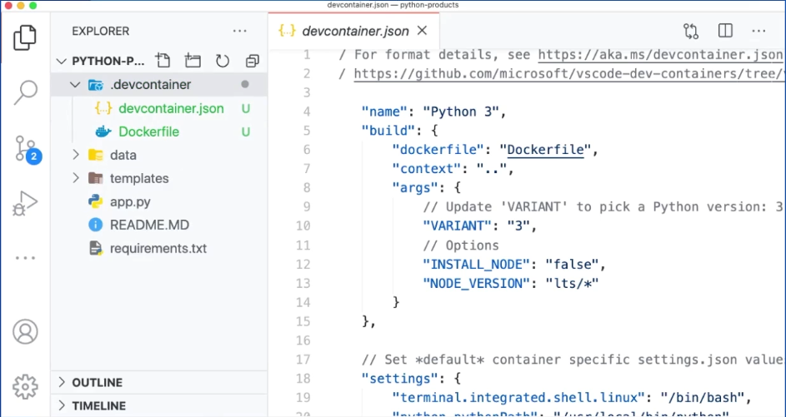
4. Devconatiner.json and Docker file define a container. If you push these files into GitHub repo then other people can pull these files down and if they have Docker and if they have

Dev-container’s extension for VS code installed in their machine, then they can open the project inside of a dev container because these two files are going to contain entire definition of container.

By this we can built the container and open the project inside the container with VS code editor connected to it.